**PYTHON – LIST COMPREHENSION**

In Python, list comprehension is concise way of creating a new list by transforming or filtering elements from an existing iterable object (Ex. A list, tuple, or string) using a single line of code.

The syntax for a list comprehension is as follows:

**new_list = [expression for item in iterable if condition == True]**

* **new_list:** the new list that will be created.
* **expression:** the operation to be performed on each item in the iterable.
* **item:** a variable that represents each element in the iterable.
* **iterable:** the object that is being iterated over.
* **condition (optional):** a filter that determines whether an item is included in the new list.

**Example - 1:-** Using a list comprehension to create a new list of squared numbers from existing list of integers.

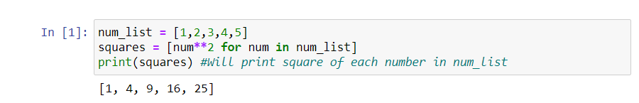

In this example, “num” is the variable that represents each element in num_list and num**2 is the expression that squares each element in num_list.

**Example – 2:-** Based on a list of students, creating a new list that contains only the students with letter “e” in their name.

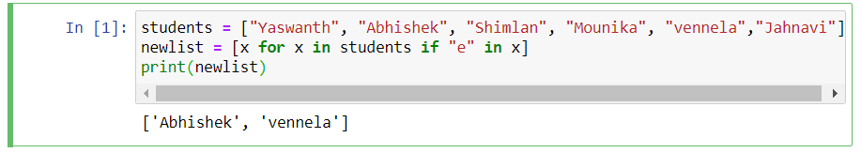

* The above example can also be written without a list comprehension as well but we have to write a for statement with a conditional test inside:

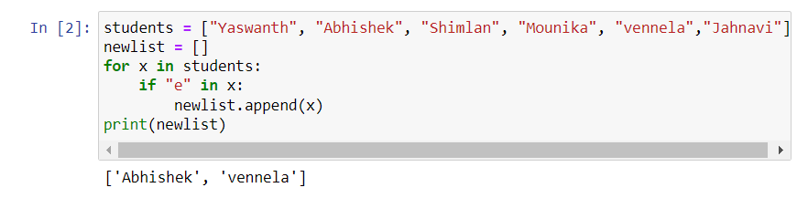

* The advantage of writing the program with line comprehension is that we can create a new list within a single line of code.

The condition is specified at the end of the list comprehension, after the iteration variable and before the closing bracket. The condition is an expression that evaluates to either True or False for each element in the iterable.

**Example :-**

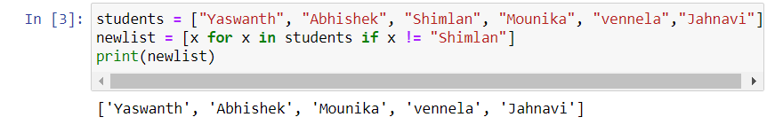

* Here, we are creating a new list from the existing list which should exclude Shimlan and the condition used here is if x **!=** “Shimlan”.
* We can also replace the name from the existing list and print in the new list with list comprehension:

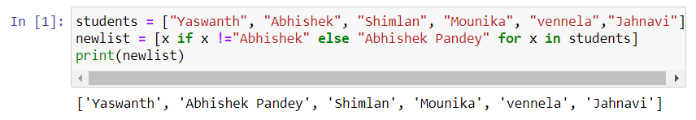

* Here, “Abhishek” in the existing list is changed to “Abhishek Pandey” in the newlist using if..else.

The expression is specified at the beginning of the list comprehension, before the “for” keyword. The expression can be any valid Python expression that returns a value.

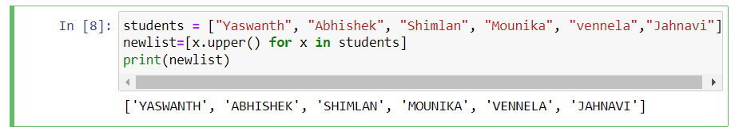

* Here, we are setting the values in the newlist to uppercase and the expression used here is x.upper( ).

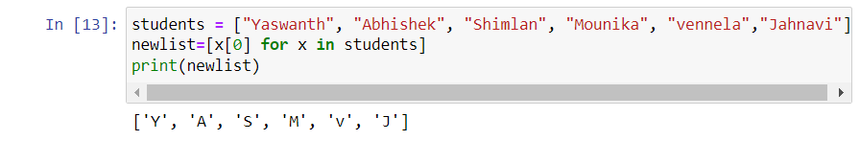

* Here, we are creating a newlist which should contain the 0th index of each element from students. We can also convert it into lowercase;

